Git and eChronos Procedures for Contributors

Contents
Setup Git (for Windows)
Downloading
Installing
Launching
Built-in Help
Standard Git Setup
Standard eChronos Procedures
Cloning eChronos from GitHub
Running Clone
Importing eChronos into Eclipse
needs content!!!
Making Changes to eChronos Files
Save the Changes
Stage the Changes
Commit the Changes Locally
Check for Changes to the Remote Repository
Use Log to Verify the Details
Pull
Check Status
Push
Merging
Not So Standard eChronos Procedures
Creating a Multi-Project Repository in Eclipse and Pushing to GitHub
Initialize the Repository in Git
Create a .gitignore file
Make the first commit
Upload the Repository to GitHub
++ Add these sections ++
Needs Content2!!!
Needs Content3!!!

Setup Git (for Windows)

Downloading
Use one of the following links, and click on the appropriate download link in your browser.
Git for Windows @ git-scm.com
Git for Windows @ github.com
Or you can just search online for 'Git for Windows' and follow an appropriate result there.

Installing
The download should have been an “EXE” file, so double-clicking will launch the installation. At this point you can choose to accept all the defaults by clicking 'Next' throughout the rest of the installation and skip to the next section. The defaults are probably fine for most users. My own installation only involved a single minor change (to add the Quick Launch button).

If you want to see some of the highlighted details of installation you can follow along through the rest of this section.

Select Components
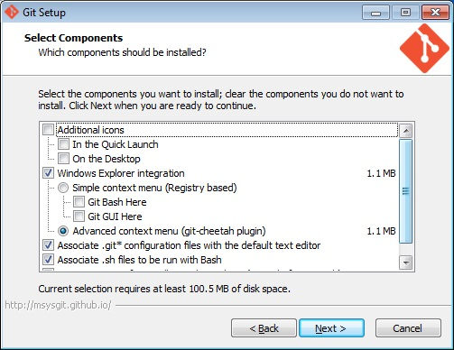
I wanted the option for Quick Launch (which is unchecked in the image by mistake), but did not want the Desktop icon.

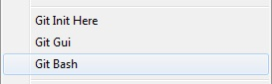
I also wanted the context menu. It shows options for Git when you right-click anywhere in Windows.

PATH Environment
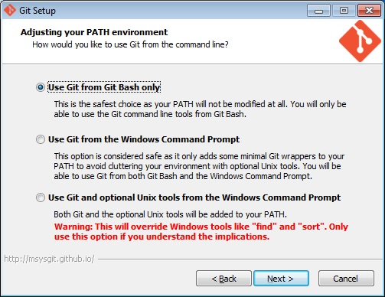
The default here is good, especially if you don't know what all this means. Basically you will use the “editor” that you are currently installing to run commands instead of using the one built into Windows.

Configuring the line ending conversions
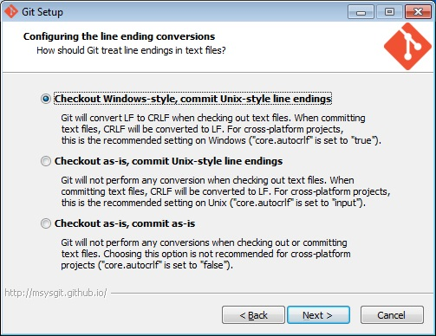
Yeah, this is gobbeldeeguk. Just accept the default. It's worked for the team so far.

Launching
After installation, both 'Git Bash' and 'Git GUI' will show up in your Start Menu
You want to run 'Git Bash' for the purposes of this guide, but are more than welcome to learn whatever the heck 'Git GUI' is good for and write your own everlovin guide.

Built-in Help
If you need quick help (probably later once you've started working with Git commands) you can enter the following commands in Bash.
Warning! The following commands will launch your browser if it isn't already open!
$ git help git - displays 'help index'
$ git help <command> - displays help for whatever command you enter

Standard Git Setup
Enter your user name.

$ git config --global user.name “Optimus Prime”

Enter your email address.

$ git config --global user.email 1GreatLeader@cybertron.net

Check what you just set.

$ git config --list
...
user.email=1GreatLeader@cybertron.net
user.name=Optimus Prime
...

There are actually 3 levels of config options:
- system (lowest precedence)
- global
- repository specific (highest)

As you can see, the global setting is in the middle. You can set the same information at the lowest level by calling: $ git config --system user.name “Megatron”, but it will be overridden by the setting at the global level. Likewise you can navigate to any specific repository on your system and call $ git config user.name “Ultra Magnus”, so that commits for that repository will have a different user name than any that do not set it specifically. Entering just the global settings should be sufficient for most users.

Calling $ git config --list shows you the settings for all 3 levels, so it may look like there is redundant information once you begin adding info to the other levels of settings.

HINT: This is a handy technique for testing what it is like for users in both situations: one that sets up the initial repository on GitHub and one that clones it. This way you can have multiple repositories on your computer with the same data, but different user names, each with the ability to make separate push/pull executions on the remote repository.

Standard eChronos Procedures

Cloning eChronos from GitHub

Running Clone
Typically the command looks something like this:

$ git clone git@github.com:Carolla/Adventurer.git eChronos

The 'eChronos' on the end is the name of a new folder that will be created in the current directory. The files from the repository on GitHub will be copied there. You can change this name to whatever you like. You can also create the directory manually in the file system, navigate to it in git, then run the clone command without the folder name at the end.

Note that if you don't specify a name at the end, git will use the name of the remote repository and create your local repository in a folder called 'Adventurer'.

Navigate into the new repository:

USER@COMPUTER ~/git
$ cd eChronos

For verification you can look at the branches in the repository:

USER@COMPUTER ~/git/eChronos
$ git branch -v
* master 8cf49fb First commit

You can also look at the remotes that were set up automatically:

USER@COMPUTER ~/git/eChronos
$ git remote -v
origin git@github.com:Carolla/Adventurer.git (fetch)
origin git@github.com:Carolla/Adventurer.git (push)

Importing eChronos into Eclipse

needs content!!!
Once you've cloned the remote repository to your computer, you can look for the files using your system's file browser.
[pic]
You can see that a working directory has been made from the repository files. These are the files you will actually modify in Eclipse. The repository files are contained in the .git folder. These will only be modified by Git using the Git Bash console.

There are 3 separate project folders for eChronos. They will have to be imported into Eclipse one at a time. The folders will also need some setup inside Eclipse to behave properly as projects and to cooperate with each other.

Making Changes to eChronos Files

Save the Changes
Save your files using Eclipse (or other editor) to update the file in your Working Directory.

Stage the Changes
Using Git, Stage the changed file or files. This prepares the files to be committed permanently to your local repository. Type git add .. Make sure to include the dot! Git will automatically scan for changes and stage them all.
[pic]
You can also specify files. git add ~/path/path/filename
[pic]

Commit the Changes Locally
Commit to submit permanent changes to your local repository. Make sure you add a commit message using -m“commit message here”.
[pic]
Otherwise you will end up in the dreaded VIM editor!!
[pic]
If this happens you can:
[type your message]
AND/OR
exit by typing “q” for “quit”

Check for Changes to the Remote Repository
You must do a fetch BEFORE checking status for this to work! Calling status without first calling fetch will not update info from the remote repository.

To see what I mean, do a git status first:
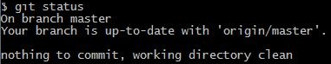

Now do the fetch:
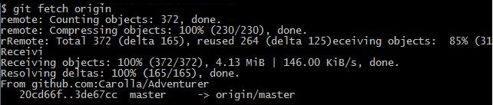

Now when you call status, there's an obvious difference!
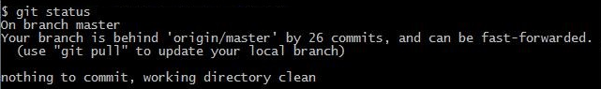

Use Log to Verify the Details
Git log shows you local commits
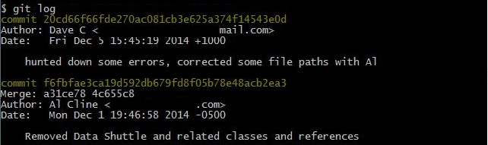

Git log origin shows remote commits
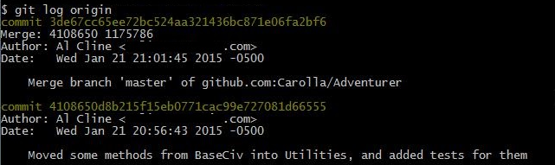

Pull
Using pull will do a combined fetch/merge. We already did a fetch, but you can use it just as easily (or more?) as merge.
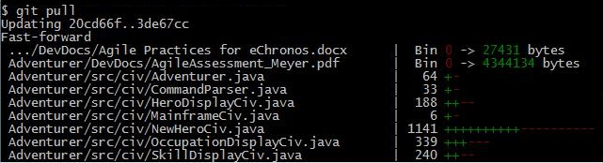

Check Status
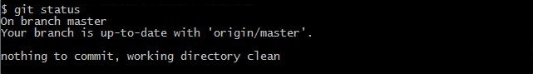

Push
This will copy your latest local commit to the remote repository on GitHub.
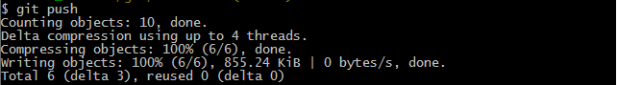
Finally! All that work, but now our changes are saved to the remote repository!

Merging
“Merging” in Git must be done locally. This means that you can't push your changes up to GitHub when others have committed new changes that you don't yet have. To push up your changes in this case you must first do a fetch, then merge locally, and then you can push.

The Quick Version
Let's do a quick demo to see how this is done. We've got a repository set up with a remote on GitHub. It's always a good idea to do a $ git status so we'll start with that.

USER@COMPUTER ~/git/MyRepo (master)
$ git status
On branch master
Your branch is ahead of 'to_gh_myrepo/master' by 1 commit.
(use "git push" to publish your local commits)

nothing to commit, working directory clean

Performing a fetch will sync us with the remote repository.

USER@COMPUTER ~/git/MyRepo (master)
$ git fetch
remote: Counting objects: 6, done.
remote: Compressing objects: 100% (1/1), done.
remote: Total 6 (delta 2), reused 6 (delta 2)
Unpacking objects: 100% (6/6), done.
From github.com:GH_User/2015_JAN_Hello_GitHub_Repo
21e8a66..7ae7c72 master -> to_gh_myrepo/master

Do another status if you want to see how it compares to your local branch (probably 'master').

USER@COMPUTER ~/git/MyRepo (master)
$ git status
On branch master
Your branch and 'to_gh_myrepo/master' have diverged,
and have 1 and 1 different commit each, respectively.
(use "git pull" to merge the remote branch into yours)

nothing to commit, working directory clean

Let's continue with our merge. We can do so by providing the name of the remote branch. Any of the following will work:
- git merge origin/master (assuming you didn't change the default names here)
- git merge @{upstream}
- git merge @{u}
Note: After running one of these commands, it should be possible to run a merge on this branch with no arguments, simply calling $ git merge

USER@COMPUTER ~/git/MyRepo (master)
$ git merge to_gh_myrepo/master
Auto-merging HelloProject_01/src/hellopackage/HelloWorld.java
CONFLICT (content): Merge conflict in HelloProject_01/src/hellopackage/HelloWorl
d.java
Automatic merge failed; fix conflicts and then commit the result.

So now Git has created a new file containing all the data from both of the files it just tried to combine. It also placed marks in the document to help us identify which edits came from which file originally. We need to open the file and edit it to keep only the changes we want. Then we can save, stage, commit and finally push back to the server.

Here's how the file looks now:
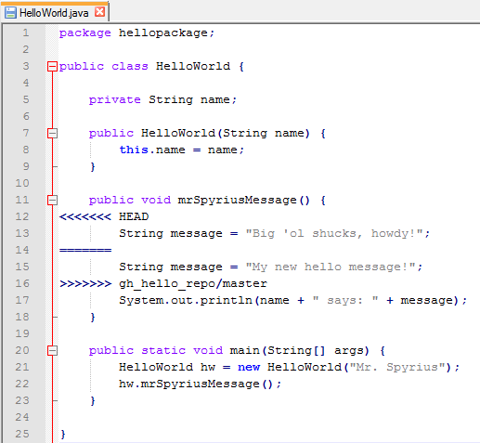

What appears between '<<<<<<< Head' and '=======' is the code from our local repository. Between '=======' and '>>>>>>> gh_hello_repo/master' is from the remote. I'll clean it up and keep the message from my local commit.

Now it looks like this:
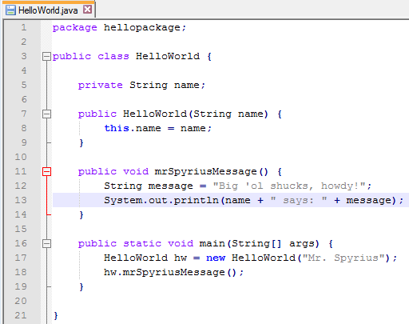

So we finish up by saving, staging the edited file (using $ git add .), and checking the status

USER@COMPUTER ~/git/MyRepo (master)
$ git status
On branch master
Your branch and 'to_gh_myrepo/master' have diverged,
and have 1 and 1 different commit each, respectively.
(use "git pull" to merge the remote branch into yours)

All conflicts fixed but you are still merging.
(use "git commit" to conclude merge)

nothing to commit, working directory clean

We run the commit

USER@COMPUTER ~/git/MyRepo (master)
$ git commit -m"Use this hello message instead"
[master f484e2b] Use this hello message instead

Check status

USER@COMPUTER ~/git/MyRepo (master)
$ git status
On branch master
Your branch is ahead of 'to_gh_myrepo/master' by 2 commits.
(use "git push" to publish your local commits)

nothing to commit, working directory clean

And finally it's time to push

USER@COMPUTER ~/git/MyRepo (master)
$ git push
Counting objects: 17, done.
Delta compression using up to 4 threads.
Compressing objects: 100% (4/4), done.
Writing objects: 100% (7/7), 599 bytes | 0 bytes/s, done.
Total 7 (delta 3), reused 0 (delta 0)
To git@github.com:GH_User/2015_JAN_Hello_GitHub_Repo.git
7ae7c72..f484e2b master -> master

The Not Remotely Quick Version
Lets say hypothetecally there's a repository called “Adventurer” on GitHub with a branch called 'master'. Suppose this 'master' branch has three commits in it. We can represent it something like this:
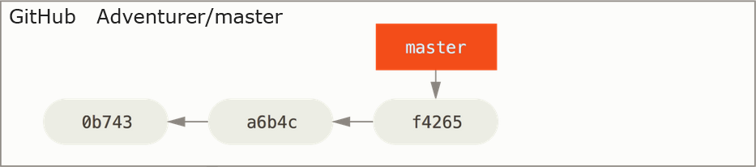

Let's also say that you've cloned the repository and now you have on your computer something like this:
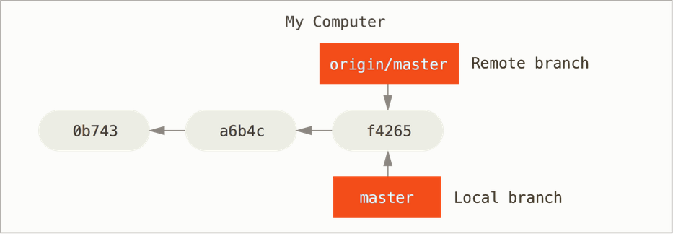

You can see that there are now two branches on your local machine that have been set up for you, 'master' and 'origin/master'. So currently there are 3 branches and 2 repositories in play.

Generally you will treat 'origin/master' as if it's the same as 'Adventurer/master'. Though the two branches can get out of sync (when someone else pushes), when you try to do a push or a pull, the two will re-sync and prevent you from making changes if a discrepancy exists.

The best way to understand the difference between these entities is to see what happens when changes are made.

Not So Standard eChronos Procedures

Creating a Multi-Project Repository in Eclipse and Pushing to GitHub
Navigate to the Git folder in your user directory
Create a new folder to be the root of your repository
Name it appropriately (Examples: eChronos, HelloProject, My_SecretProj_Repo)
Create folders for each of the Projects inside the new directory
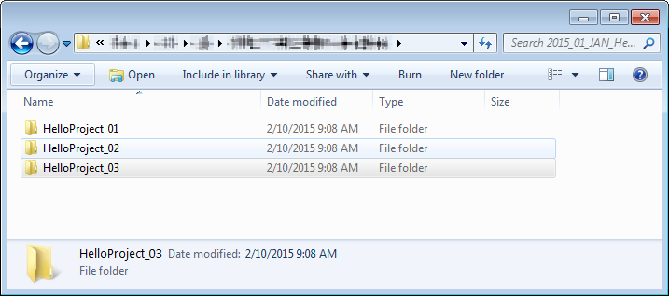
In Eclipse, create projects by right-clicking and selecting New > Java Project
Make sure to un-check the “Use default location” checkbox
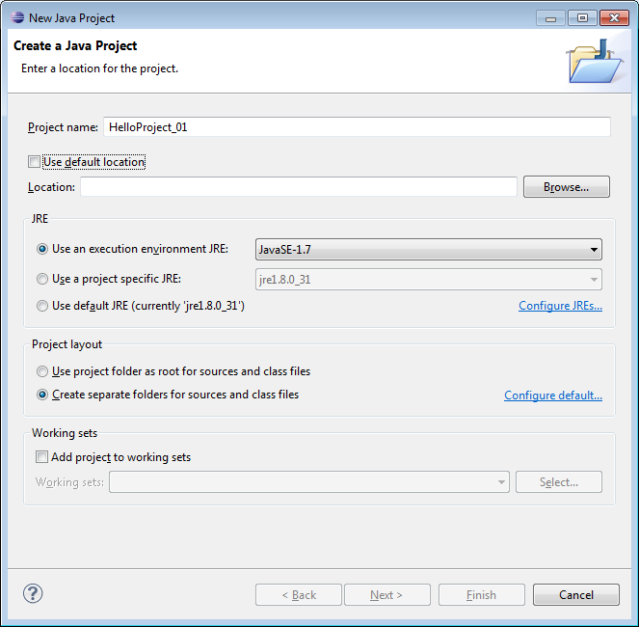
Click Browse next to “Location” and select one of the project folders you just created
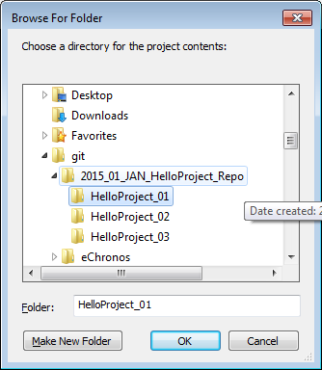

Initialize the Repository in Git
Open Bash
Navigate to the directory containing the Project Folders
Use git init to set up the empty repository

USER@COMPUTER ~/git/MyRepo
$ git init

There will now be a ".git" folder next to your project folders (assuming you are setup to see hidden folders).
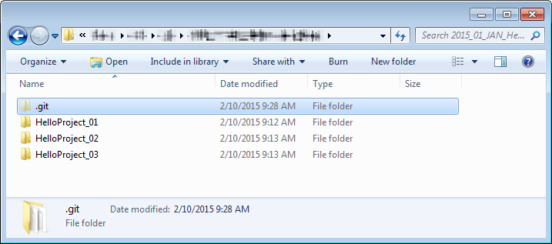

What's in the .git folder constitutes your "local repository". The project folders are your “working directory”. When you do your first commit to the local repository, it will then contain an effective “backup” of the files in your working directory.

It is worth noting that a “branch” has also been automatically been created for you called “master”. Until you create or clone and afterwards switch to another branch, all your work will be done on master.

Create a .gitignore file
Use a text editor to manually create a .gitignore file in this root repository directory.
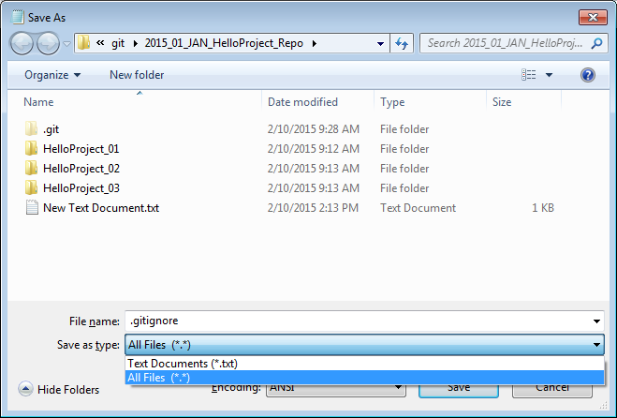

Make sure to choose file type “All Files (*.*)”. Otherwise Notepad will add .txt to the end.

Special characters:
- Start a line with # for a comment
- Use * as a wildcard for zero or more characters
- End with / to specify directory rather than file
- Use ! to ignore a pattern
- Use \ as escape (i.e. \!important!.txt)

Sample .gitignore:
# ignore all bin folders #
#################
bin/

# ignore all .class files #
################
*.class

# ignore some eclipse files #
###################
.classpath
.project

# ignore the batman folder, but not the bruce folder inside it #
###########################################
batman/
!/bruce

Make the first commit
In this case you have to stage your files first.

USER@COMPUTER ~/git/MyRepo (master)
$ git add .

Do the commit and add a commit message (-m “message”).

USER@COMPUTER ~/git/MyRepo (master)
$ git commit -m “First commit”

Upload the Repository to GitHub
Login to GitHub and create a new Repository there on the website. There are several ways to do this. You can use the drop-down next to your user name, or the handy green button. Both are available from the main page after logging in. You can also navigate to the Repositories page and create it there. The image shows the latter option.


Fill in a name for the repository and hit the Create repository button. Note that we're NOT checking the box to initialize with a README, because it can interfere with our push.
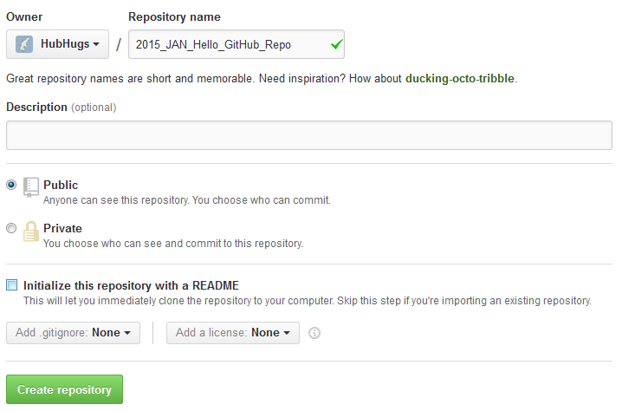

Once the repository is created, GitHub suggests ways to populate it. For the most part, we will be following their second suggestion.
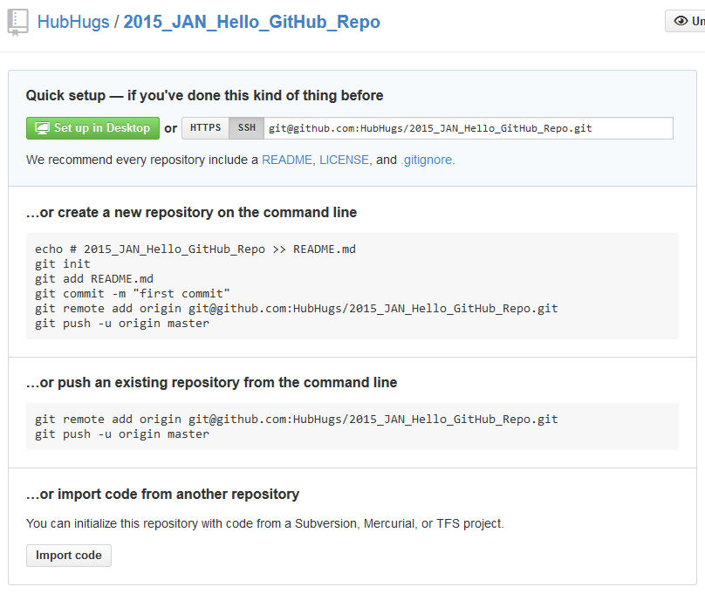

First we'll connect our local “master” branch to the remote repository. GitHub uses the nickname “origin”. I'll use “gh_hello_repo”. Copy the repository address from the top of the page.

In Bash type in the first part of the command. Use your own short name for the repository instead of gh_hello_repo:

USER@COMPUTER ~/git/MyRepo (master)
$ git remote add gh_hello_repo

Then paste in the address from GitHub. You can do so in Bash by right-clicking the top of the window and selecting Edit > Paste.
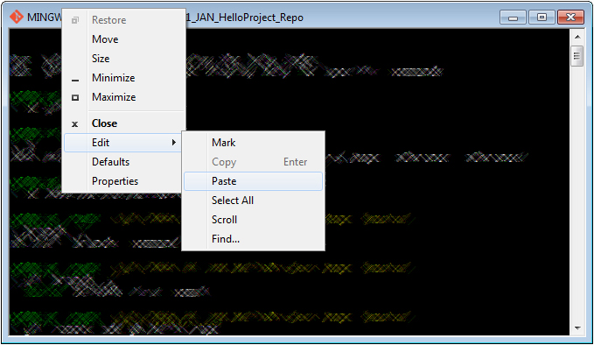

So the final command should look something like this:

USER@COMPUTER ~/git/MyRepo (master)
$ git remote add gh_hello_repo git@github.com:HubHugs/2015_JAN_Hello_GitHub_Rep
o.git

Afterwards we can check for remote branches by using: git remote -v

USER@COMPUTER ~/git/MyRepo (master)
$ git remote -v
gh_hello_repo git@github.com:HubHugs/2015_JAN_Hello_GitHub_Repo.git (fetch)
gh_hello_repo git@github.com:HubHugs/2015_JAN_Hello_GitHub_Repo.git (push)

And now we can do our push. Make sure to use the -u option. This will setup a “tracking” relationship between the two branches. Tracking allows push and pull operations without the need for additional command input.

USER@COMPUTER ~/git/MyRepo (master)
$ git push -u gh_hello_repo master

So we are telling the push command to use the “gh_hello_repo” repository and the “master” branch on that repository; not to be confused with the “master” branch of our local repository. The format is: push -u [remote repository] [remote branch]

Below is the command with the full output:

USER@COMPUTER ~/git/MyRepo (master)
$ git push -u gh_hello_repo master
Counting objects: 15, done.
Delta compression using up to 4 threads.
Compressing objects: 100% (6/6), done.
Writing objects: 100% (15/15), 958 bytes | 0 bytes/s, done.
Total 15 (delta 2), reused 0 (delta 0)
To git@github.com:HubHugs/2015_JAN_Hello_GitHub_Repo.git
* [new branch] master -> master
Branch master set up to track remote branch master from gh_hello_repo.

Now if we refresh the repository page in our browser it shows the updated info:
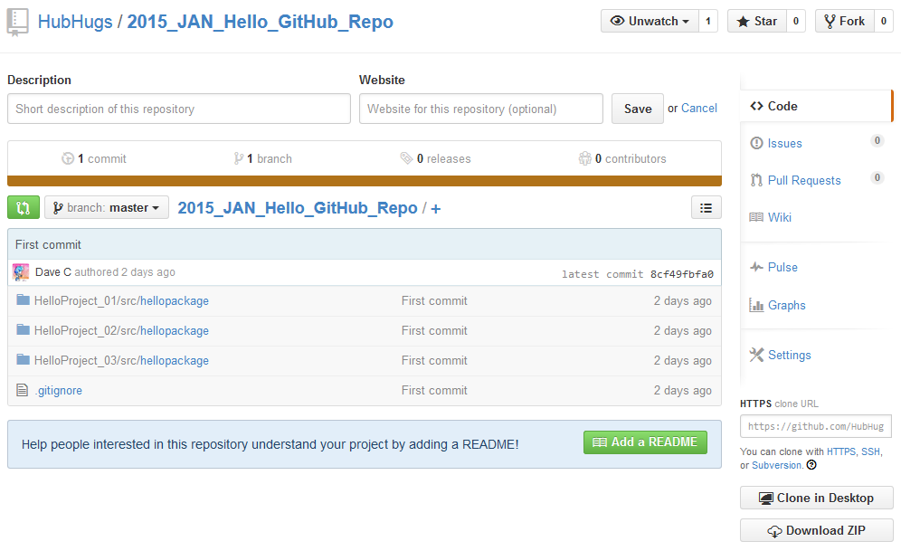

As a final note it is probably a good idea to go into the settings for your repository on GitHub and in the “Features” section set it to “Restrict editing to collaborators only” unless you want the general public to be able to make changes as they please.
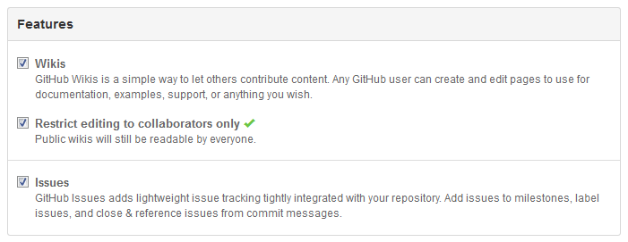

++ Add these sections ++
Merging two files that have conflicts.
Deleting Files
Un-deleting Files
Refreshing a previously deleting file, that is, restoring a backed up version.

Contents_NeedsContent2

Contents_NeedsContent3

Needs Content2!!!

Needs Content3!!!

